SNOWFLAKE ARCHITECTURE
On continuation of previous post snowflake_4

Credit usage scenarios:
Case1:
Considering a small size warehouse of single cluster and finding out total credits consumed in 2 hrs
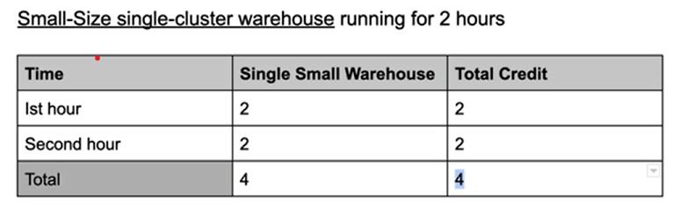
Case2:
Considering multi cluster warehouse (considering 3 WH’s) and finding out total credits in 2 hrs
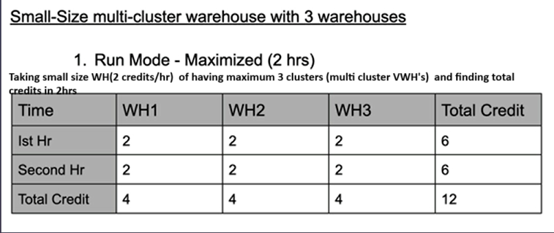
Case3:
Considering an auto scale mode scenario where depending on load, WH1 runs continuously for 2 hrs, WH2 runs only in 2nd hr as per load, WH3 runs for 30 min during 2nd hr.
Now as WH1 charges 2(small size in 1st hr) +2(small size in 2nd hr) =4 credits/2hrs
WH2 charges 0(no usage in 1st hr) +2 (small size in second hr) = 2 credits/2hrs
WH3 charges 0(no usage in 1st hr) + 1(2 credits per hr implies 1 credit per ½ hr) = 1 credit/2hrs
Total credits = 4+2+1 = 7 credits/2hrs

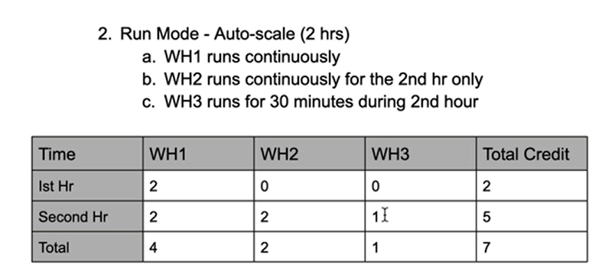
Case4:
Considering total time of 3hrs out of which after 1.5 hr, the size of multi cluster VWH’s (considering 3 as example) is changed from small to medium size, WH1 runs continuously for 3 hrs & WH2 runs from 2nd hr provided size is changed after 1.5 hr & WH3 runs from 3rd hr
Now
For WH1,
2 (small size in 1st hr) +1 (in 2nd hr, for 30 min it is small size hence 2/2=1 credit/30min) +2 (in 2nd hr, remaining 30 min is charged for medium size which is 4credits/hr = 2 credits/30min) +4(medium size in 3rd hr) = 9 credits/3hrs
For WH2,
0(no usage in 1st hr) + same as above = 7 credits/3hrs
For WH3,
0(no usage in 1st hr) + 0(no usage in 2nd hr) + 1(in 3rd hr size is medium and charges 4 credits/hr =2 credits/30min =1 credit/15min) = 1 credit/3hrs

